Experiment 2
1.Table Instructor
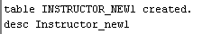

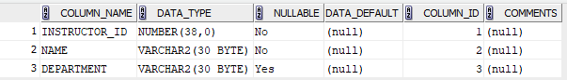

2. course

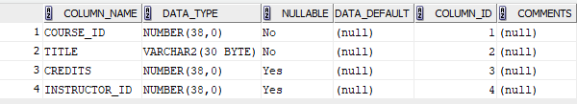

3. student
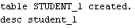

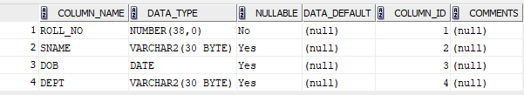

4.Enrollment

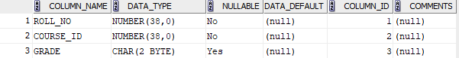

5. Indices
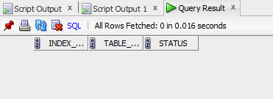

6. drop

